Introducing the MC20x20V-20D

1. Introducing the MC20x20V-20D 1
1.7. Using the MC20x20V-20D 4
1.8. Sharing resources – all resources can be used 6
2. Software features 9
2.7. Dynamic Bandwidth Sharing 9
2.8. VDOC 10
2.9. Powerboost 13
2.10. Rate adapt 13
2.11. Subscriber Traffic Management 14
3. Configuration 15
3.7. References 16
3.8. Concepts 16
4. Examples 19
4.7. A basic MC20x20V configuration. 20
4.8. A basic MC88V configuration. 24
4.9. Shared (spanned) 8 channel bonding into 4 service areas 28
4.10. Shared (spanned) 4 channel IPTV into 4 service areas 33
4.10.1. Basic Multicast Forwarding 33
4.10.2. Multicast DSID Forwarding 34
4.10.3. Explicit Tracking 35
4.10.4. Multicast QoS 35
4.10.5. Multicast BPI+ 37
4.10.6. Multicast Authorization 38
4.10.7. Static Multicast Session 38
4.10.8. VIDEO server: 39
4.10.9. UBR10012 configuration sample 1 (VDOC) 39
4.10.10. UBR10012 configuration sample 2 50

The MC20x20V-20D is a new generation line card for the uBR10012 CMTS that provides full DOCSIS 3.0 capability to the uBR10012 CMTS.

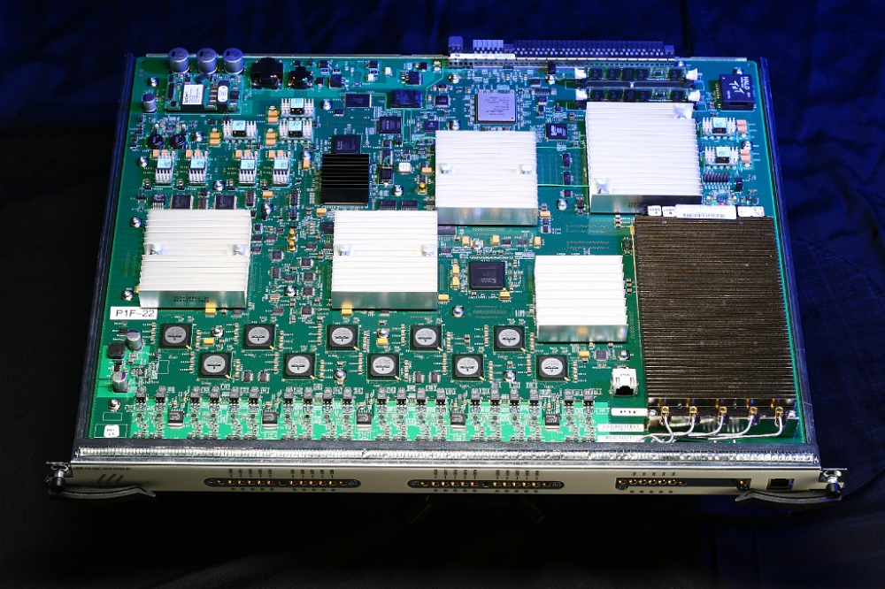

  - 20 Downstream Channels
    - 5 Physical connectors, 4 channels per port
    - 20 Integrated-Cable interfaces
    - 30 DS bonding groups
  - 20 Upstream Channels
  - Virtual interface and Frequency stacking supported
  - Supports DOCSIS 3.0 Features
    - DS bonding, US bonding, BPI etc.
  - 5 Mac Domains per line card with flexibleNote allocation of downstream and upstream to a MAC domain.

Using the MC20x20V-20D
The MC20x20V-20D can be used to provide 20 downstreams and 20 upstreams into a service area in a variety of configurations.
A basic configuration provides 4 channel upstream and 4 channel downstream bonding into 5 service areas supported by 4 upstream per service area. Up to EightNote active line cards can be installed in a uBR10012 chassis in non high availability mode thus up to 40 service areas can be supported per chassis: 160 downstream and 160 upstream configured as 4x4 channel bonding or as 4x4 for DOCSIS 2.0 service.

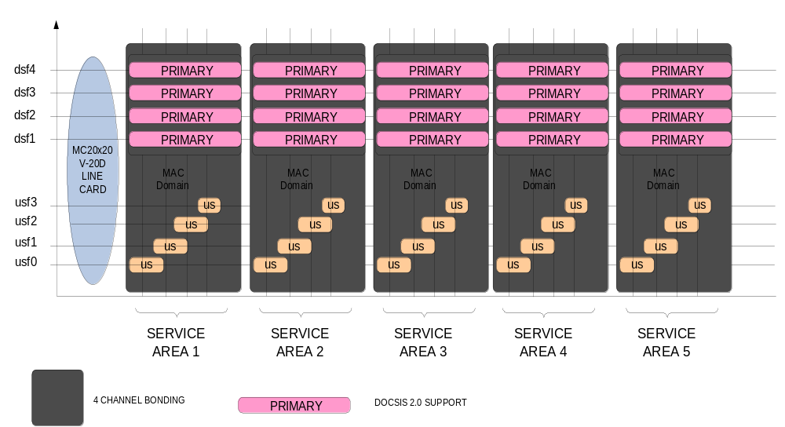
But this is not the only variation that can be supported.
The MC20x20V-20D can support up to 8 upstream per MAC domain just as the older MC5x20H-D line card. In addition two upstream channels can be frequency stacked on the one connector but note that there is still a limit of 20 upstreams per line card thus only 10 physical connectors can be frequency stacked.

As can be seen from the following configuration, the MC20x20V-20D can be configured to provide 8 channel downstream bonding.
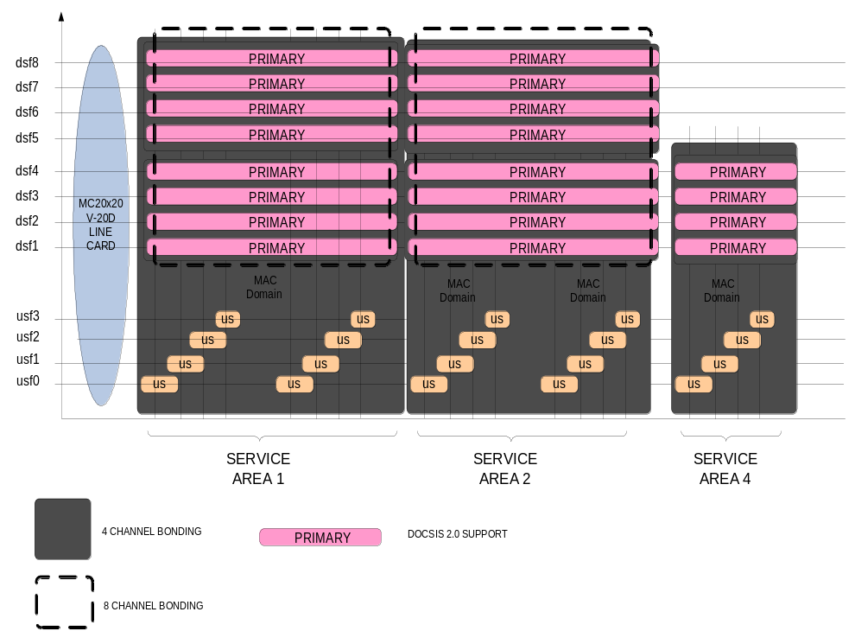
The line card will support 2 service areas with 8x8 and one service area of 4x4. If only 8 channel bonding is required then a 4x4 service area is effectively stranded (not used) and this is often not desirable.
In fact up to 20 channel downstream bonding can be configured by configuring all downstream to be available in the one 8 upstream service area but again we will be stranding 12 upstream connectors and again this is not desirable.

Sharing resources – all resources can be used
The MC20x20V-20D line card can be configured in a sharing mode of operation to make best use of all the upstream and downstream resources (no stranded resources) thus providing the best cost benefit to a customer.
The level of sharing is only limited by the following rules:
- Sharing within one line card only
- A downstream can be primary in one MAC domain only
- The number of available downstream channels in the HFC plant downstream spectrum
In the following example, downstream resources are shared to provide 8 channel bonding in each of the 5 service areas supported by a single line card.

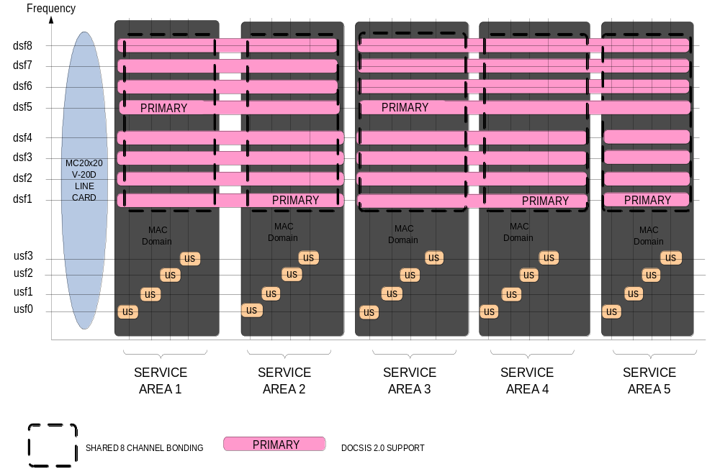

The following configuration is another variation on shared downstreams. This configuration uses all available upstream and downstream resources in each line card and provides:
5 upstream per service area and thus up to 5 channelNote upstream bonding in 4 service areas;
- 4 channel downstream bonding into 4 service areas
- 4 DOCSIS 2.0 capable downstream into 4 service areas
- DOCSIS 2.0 and DOCSIS 3.0 capacity shared across the 4 primary downstreams
- 8 channel bonding in each of the 4 service areas with capacity shared across the 4 service areas and;
- Shared 4 channel broadcast (IPTV) into each of the 4 service areas with broadcast capacity shared with the 8 channel bonding.
This configuration can be used to support DOCSIS 2.0 modems, 8x4 DOCSIS 3.0 modems and linear IPTV into the 4 service areas.

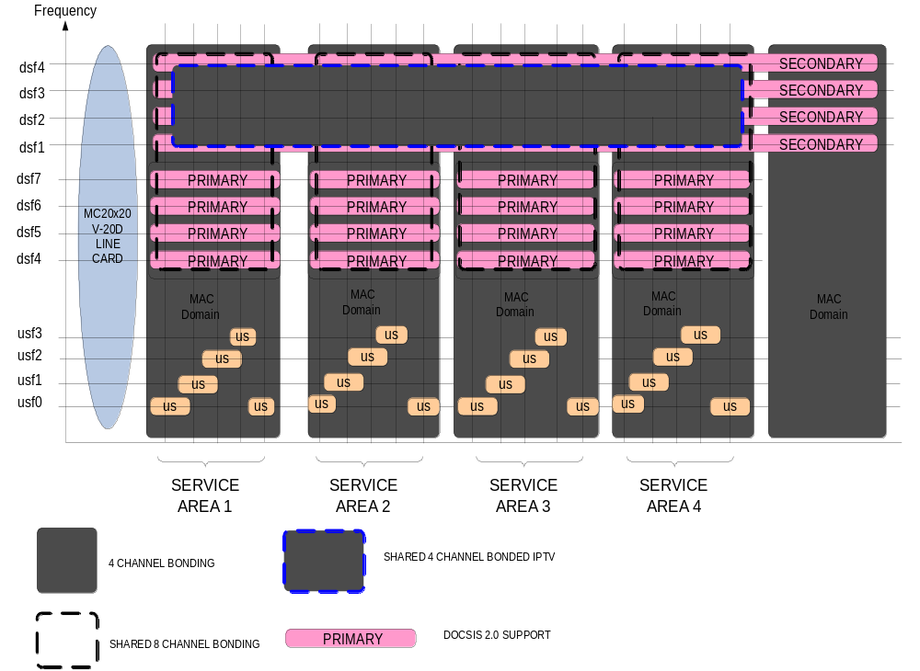

There are many such variations possible. Another option is shown following:
- 3 upstream per service area of 8,6 and 6 upstreams
- 8 channel downstream bonding into all service areas
- Minimum of 4 DOCSIS 2.0 capable downstream into all service areas
- DOCSIS 2.0 and DOCSIS 3.0 capacity shared across the 4 primary downstreams as required

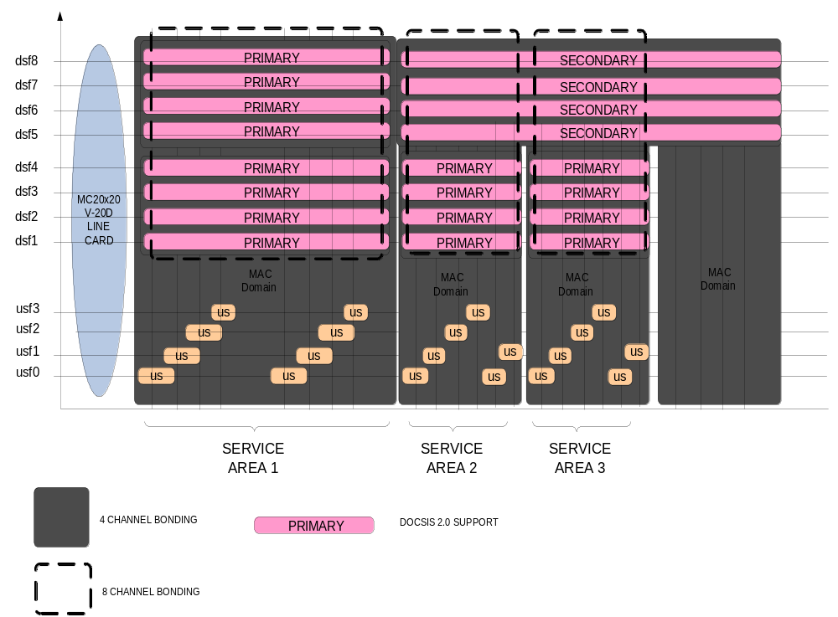

The common feature in the above two examples is the ability to use all the line card resources.

Software features

Dynamic Bandwidth Sharing
The above examples makes use of the Cisco ability to share bandwidth to provide an 8 channel bonded data service even though a 4 channel bonding data service is nominally deployed.
Dynamic bandwidth sharing also allows the 4 channel bonding downstream to support DOCSIS 2.0 service with bandwidth being shared between the different types of operation of the downstream. Limits can be set in either case providing reserved bandwidth for narrow cast services and wideband or bonding operation.

http://www.cisco.com/en/US/docs/ios/cable/configuration/guide/cmts_dyn_bw_sharing.html

VDOC

VDOC provides a means to economically provide linear video or broadcast video to subscribers in a CMTS serving area.
The MC20x20V-20D deployment examples detailed above and copied following shows a shared 4 channel bonding group – this bonding group shared across the 4 service areas supported by the one line card.

The uBR10012 can be configured to support 8x4 modems to provide 4 channels of unicast high speed data and 4 channels of bonded broadcast data.

The following figure shows this configuration in more detail at a system level:

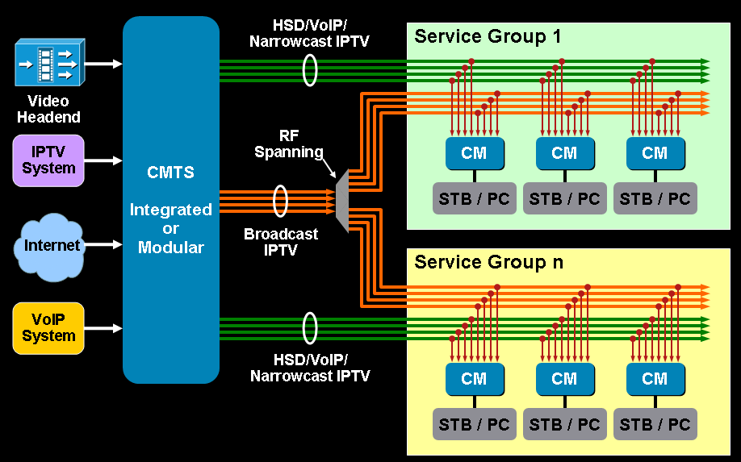

If the shared or spanned bonded downstream contains multiple IPTV streams, then an IPTV STB attached to a cable modem can potentially view any of the IPTV streams contained in the bonded 4 channel downstream.
Such a configuration would be able to support approximately 50 standard definition IPTV Variable Bit Rate (VBR) streams with the CMTS now providing the STATMUX ability that is often associated with the MUX of MPEG streams into a downstream channel. The other big advantage of the CMTS based STATMUX of multiple streams into a bonded downstream of high data capacity is that more channels can be packed into the same bandwidth than would be achieved by packing them into N x discrete downstreams. i.e. a single downstream will carry approximately 10 SD IPTV streams and 4 such downstreams only 40 compared to 50 for the bonded channel..
Where a single 4 channel bonded downstream is not sufficient to provide the number of IPTV linear streams required, additional capacity can be added in the form of sharing multiple 4 channel bonded downstreams. This upgrade leverages the fact that 8x4 modems have two wideband tuners and effectively what happens is that one tuner is locked to providing 4 channel bonded data service whilst the second tuner can be reprogrammed using standard DOCSIS 3.0 protocols to tune to any 4 channel bonded channel as required.

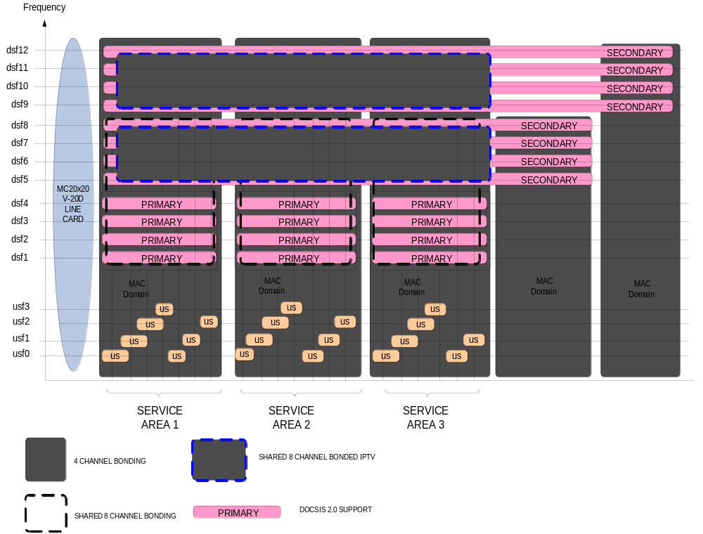

Such a dual bonded channel upgrade can be delivered in the above MC20X20V based configuration but consideration should be given to a M-CMTS solution if such a high capacity linear IPTV requirement is planned. In an M-CMTS solution a bonded downstream can be shared across an entire chassis – not just a single line card.
Regardless of the solution selected once multiple bonded downstream are provided the uBR10012 CMTS is smart enough to track via IGMP requests (as a result of STB channel change) what IPTV stream the subscriber wishes to watch and will reconfigure the modem to receive the requested bonded downstream. Thus more capacity than one shared bonded downstream can be effectively delivered to a subscriber.

Powerboost

Allow subscribers to have access to additional downstream bandwidth for short time durations i.e. Improves the user experience – get a web page faster without affecting the AVERAGE download speed.

Powerboost can be configured by:
  - CLI
  - Service Class Name
  - Per service flow in modem configuration file

More information can be found here:

http://www.cisco.com/en/US/docs/ios/cable/command/reference/cbl_03_cable_d.html

Rate adapt
Under DOCSIS 2.0/3.0, a cable modem is not allowed to issue another request until an outstanding one has been granted. This leads to a delay in requesting further bandwidth until the outstanding request is received by the CMTS, then granted on a MAP sometime in the future. Maps are sent out every 2ms, so the turnaround time is roughly 4ms.
The Cisco CMTS can provide increased upstream speed when the upstream is not busy by issuing more grants than requested by a modem thus allowing more data to be transferred. This feature is configured globally or on a per upstream basis using the command “rate-adapt”
http://www.cisco.com/en/US/docs/ios/cable/configuration/guide/cmts_upstream_rate_adapt.html

Subscriber Traffic Management

As downstream data rates increase, the time period it takes for a subscriber to exceed download caps reduces - and may drop to such a short time that the operator's traditional billing methods will not catch this event and traditional rate limiting and / or warnings sent to the subscriber will be implemented too late. This is very relevant in regions where penalty rates apply once a download cap is exceeded. The STM feature will remove the need to worry about this and adds further value to Cisco CMTS.
The Subscriber Traffic Management feature allows service providers to identify and control subscribers who exceed the maximum bandwidth allowed under their registered quality-of-service (QoS) profiles. This feature supplements current techniques such as Network-Based Application Recognition (NBAR) and access control lists (ACLs), to ensure that a minority of users do not consume a majority of the cable network's bandwidth.
Current subscriber controls, such as NBAR and ACLs, examine all packets coming into the CMTS. These techniques can curb a large volume of problem traffic, but they are not as effective in dealing with the latest generation of peer-to-peer file-sharing applications that can place heavy demands on a network's available bandwidth. The Subscriber Traffic Management feature allows service providers to focus on a minority of potential problem users without impacting network performance or other users who are abiding by their service agreements.
In addition, when a cable modem goes offline and remains offline for 24 hours, the Cisco CMTS deletes its service flow IDs from its internal databases, and also deletes the modem's traffic counters. This can allow some users to exceed their bandwidth limits, go offline, and come back online with new counters.
The Subscriber Traffic Management feature helps to thwart these types of theft-of-service attacks by implementing a penalty period for cable modems that violate their service level agreements (SLAs). Even if the cable modem goes offline, its counters are still reset, and the CMTS continues to enforce the penalty period.

http://www.cisco.com/en/US/docs/cable/cmts/feature/ubsubmon.html

Configuration

References

[1] | http://www.cisco.com/en/US/docs/interfaces_modules/cable/broadband_processing_engines/ubr_mc20x20v/configuration/guide/mc20x20v_cfg.html
[2] | http://www.cisco.com/en/US/docs/ios/cable/configuration/guide/VDOC_dbc_feature_ps2209_TSD_Products_Configuration_Guide_Chapter.html

Concepts

http://www.cisco.com/en/US/docs/interfaces_modules/cable/broadband_processing_engines/ubr_mc20x20v/configuration/guide/mc20x20v_cfg.html

The configuration concepts are fundamentally the same as the SPA-24XDS-SFP downstream – i.e. allocation of the “downstream integrated-cable” ( for spa would be downstream modular-cable) to an “interface cable” defines a primary downstream and the wideband groups define the bonding groups and the fiber-node spec defines what a modem can “see” and what is advertised in the downstream MDD messaging.

What the MX20X20V hardware will look like:
!
card 1 4jacket-1
card 1/0 SPA-1XTENGE-XFP-V2
card 1/1 24rfchannel-spa-1
card 1/2 24rfchannel-spa-1
card 1/3 24rfchannel-spa-1
card 1/1 2cable-dtcc
card 2/1 2cable-dtcc
card 3 2jacket-1
card 3/0 24rfchannel-spa-1
card 3/1 24rfchannel-spa-1
card 6/0 5cable-mc520u-d
card 6/1 5cable-mc520h-d
card 8/1 ubr10k-clc-mc2020v license 20X20
cable admission-control preempt priority-voice
!

SPA based configuration:

controller Modular-Cable 3/1/0
rf-channel 0 cable downstream channel-id 217
rf-channel 1 cable downstream channel-id 218
rf-channel 2 cable downstream channel-id 219

Compared to MC20X20V configuration:

controller Integrated-Cable 8/1/0
rf-channel 0 cable downstream channel-id 80
rf-channel 0 frequency 453000000 annex B modulation 256qam interleave 32
no rf-channel 0 rf-shutdown
rf-channel 1 cable downstream channel-id 81
rf-channel 1 frequency 459000000 annex B modulation 256qam interleave 32
no rf-channel 1 rf-shutdown
rf-channel 2 cable downstream channel-id 82
rf-channel 2 frequency 465000000 annex B modulation 256qam interleave 32
no rf-channel 2 rf-shutdown
rf-channel 3 cable downstream channel-id 83
rf-channel 3 frequency 471000000 annex B modulation 256qam interleave 32
no rf-channel 3 rf-shutdown

!
Upstream specs here:

interface cable 8/1/0
cable upstream max-ports 4
cable upstream bonding-group 1
upstream 0
upstream 1
upstream 2
upstream 3
attributes 800000AB
cable upstream resiliency channel-down-detect 32
!
cable upstream 0 connector 0
cable upstream 0 frequency 14600000
cable upstream 0 channel-width 6400000 6400000
cable upstream 0 load-balance group 1
cable upstream 0 docsis-mode atdma
cable upstream 0 minislot-size 1
cable upstream 0 range-backoff 3 6
cable upstream 0 modulation-profile 224 225 226
cable upstream 0 attribute-mask AB
no cable upstream 0 shutdown
!

and wideband interface defined like this:

interface Wideband-Cable8/1/0:0
cable bonding-group-id 1377
cable rf-channel 0
cable rf-channel 1
cable rf-channel 2
cable rf-channel 3
!

With the option of adding downstream from other controllers (MAC domains) on the same line card like this:

interface Wideband-Cable8/1/0:0
cable bonding-group-id 1377
cable rf-channel 0
cable rf-channel 1
cable rf-channel 2
cable rf-channel 3
cable rf-channel controller 4 channel 0 bandwidth-percent 1
cable rf-channel controller 4 channel 1 bandwidth-percent 1
cable rf-channel controller 4 channel 2 bandwidth-percent 1
cable rf-channel controller 4 channel 3 bandwidth-percent 1
cable downstream attribute-mask 800000AB

Primary 20x20 DS are defined like this

interface Cable8/1/0
downstream integrated-cable 8/1/0:0 ←- defines one primary
no cable packet-cache
cable upstream max-ports 4
cable upstream 0 connector 0
cable upstream 0 channel-width 1600000 1600000
cable upstream 0 docsis-mode tdma
cable upstream 0 minislot-size 4
cable upstream 0 range-backoff 3 6
cable upstream 0 modulation-profile 21
cable upstream 0 shutdown

For a fiber-node - the following will configure a 4 channel bonding group with the primary marked as above being downstream integrated-cable 8/1/0:0 due to the fact this rf-channel is defined under the interface cable 8/1/0 specification

cable fiber-node 1
description Serving Area 1
downstream Inrgrated-Cable 8/1/0 rf-channel 0-3
upstream Cable 8/1 connector 0-3

Examples

A basic MC20x20V configuration.

controller integrated-cable 8/1/0
rf-channel 0 cable downstream channel-id 80
rf-channel 0 frequency 453000000 annex B modulation 256qam interleave 32
no rf-channel 0 rf-shutdown
rf-channel 1 cable downstream channel-id 81
rf-channel 1 frequency 459000000 annex B modulation 256qam interleave 32
no rf-channel 1 rf-shutdown
rf-channel 2 cable downstream channel-id 82
rf-channel 2 frequency 465000000 annex B modulation 256qam interleave 32
no rf-channel 2 rf-shutdown
rf-channel 3 cable downstream channel-id 83
rf-channel 3 frequency 471000000 annex B modulation 256qam interleave 32
no rf-channel 3 rf-shutdown

controller Integrated-Cable 8/1/1
rf-channel 0 cable downstream channel-id 84
rf-channel 0 frequency 453000000 annex B modulation 256qam interleave 32
no rf-channel 0 rf-shutdown
rf-channel 1 cable downstream channel-id 85
rf-channel 1 frequency 459000000 annex B modulation 256qam interleave 32
no rf-channel 1 rf-shutdown
rf-channel 2 cable downstream channel-id 86
rf-channel 2 frequency 465000000 annex B modulation 256qam interleave 32
no rf-channel 2 rf-shutdown
rf-channel 3 cable downstream channel-id 87
rf-channel 3 frequency 471000000 annex B modulation 256qam interleave 32
no rf-channel 3 rf-shutdown

controller Integrated-Cable 8/1/2
!as above but for incrementing channel-id

controller Integrated-Cable 8/1/3
!as above but for incrementing channel-id

controller Integrated-Cable 8/1/4
!as above but for incrementing channel-id

interface cable8/1/0
! define the primary capable downstream
downstream integrated-cable 8/1/0:0
downstream integrated-cable 8/1/0:1
downstream integrated-cable 8/1/0:2
downstream integrated-cable 8/1/0:3
!
! set up the upstream bonding
!
cable upstream max-ports 4
cable upstream bonding-group 1
upstream 0
upstream 1
upstream 2
upstream 3
attributes 800000AB
cable upstream resiliency channel-down-detect 32
!
cable upstream 0 connector 0
cable upstream 0 frequency 14600000
cable upstream 0 channel-width 6400000 6400000
cable upstream 0 load-balance group 1
cable upstream 0 docsis-mode atdma
cable upstream 0 minislot-size 1
cable upstream 0 range-backoff 3 6
cable upstream 0 modulation-profile 224 225 226
cable upstream 0 attribute-mask AB
no cable upstream 0 shutdown
!
cable upstream 1 connector 1
cable upstream 1 frequency 21000000
cable upstream 1 channel-width 6400000 6400000
cable upstream 1 load-balance group 1
cable upstream 1 docsis-mode atdma
cable upstream 1 minislot-size 1
cable upstream 1 range-backoff 3 6
cable upstream 1 modulation-profile 224 225 226
cable upstream 1 attribute-mask AB
no cable upstream 1 shutdown

!
cable upstream 2 connector 2
cable upstream 2 frequency 27400000
cable upstream 2 channel-width 6400000 6400000
cable upstream 2 load-balance group 1
cable upstream 2 docsis-mode atdma
cable upstream 2 minislot-size 1
cable upstream 2 range-backoff 3 6
cable upstream 2 modulation-profile 224 225 226
cable upstream 2 attribute-mask AB
no cable upstream 2 shutdown

!
cable upstream 3 connector 3
cable upstream 3 frequency 33800000
cable upstream 3 channel-width 3200000 3200000
cable upstream 3 load-balance group 1
cable upstream 3 docsis-mode tdma-atdma
cable upstream 3 minislot-size 2
cable upstream 3 range-backoff 3 6
cable upstream 3 modulation-profile 124 125 126
cable upstream 3 attribute-mask AB
no cable upstream 3 shutdown
!
cable sid-cluster-switching max-request 0
cable sid-cluster-switching max-outstanding-byte 0
cable sid-cluster-switching max-total-byte 0
cable sid-cluster-switching max-time 0
Future → Need to detail what is happening here
0 is the default condition though
!
interface cable8/1/1
! as above but upstream number incrementing
!
interface cable8/1/2
! as above but upstream number incrementing
!
interface cable8/1/3
! as above but upstream number incrementing
!
interface cable8/1/4
! as above but upstream number incrementing

interface integrated-cable 8/1/0:1
description ** narrowband modems here
cable bundle 1
cable dynamic-bw-sharing
! this is a primary downstream and at least 4% needed for primary operation
cable rf-bandwidth-percent 4
!
interface Integrated-Cable 8/1/0:2
description ** narrowband modems here
cable bundle 1
cable dynamic-bw-sharing
! this is a primary downstream and at least 4% needed for primary operation
cable rf-bandwidth-percent 4
!
interface Integrated-Cable 8/1/0:3
description ** narrowband modems here
cable bundle 1
cable dynamic-bw-sharing
! this is a primary downstream and at least 4% needed for primary operation
cable rf-bandwidth-percent 4
!
interface Integrated-Cable 8/1/0:4
description ** narrowband modems here
cable bundle 1
cable dynamic-bw-sharing
! this is a primary downstream and at least 4% needed for primary operation
cable rf-bandwidth-percent 4
!

interface Wideband-Cable8/1/0:0
cable bonding-group-id 1377
cable dynamic-bw-sharing
! all rf-channel primary so we must specify bandwidth percent
! if not then 100% assumed for bonding
cable rf-channel 0 bandwidth percent 1
cable rf-channel 1 bandwidth percent 1
cable rf-channel 2 bandwidth percent 1
cable rf-channel 3 bandwidth percent 1
cable downstream attribute-mask 800000AB
Future → Detail why attribute mask being set

!
interface Wideband-Cable8/1/1:0
cable bonding-group-id 1378
cable rf-channel 0
cable rf-channel 1
cable rf-channel 2
cable rf-channel 3
cable downstream attribute-mask 800000AB
!
interface Wideband-Cable8/1/2:0
! as above but incrementing the bonding-group-id
!
interface Wideband-Cable8/1/3:0
! as above but incrementing the bonding-group-id
!
interface Wideband-Cable8/1/4:0
! as above but incrementing the bonding-group-id

cable fiber-node 1
description Serving Area 1
downstream Integrated-Cable 8/1/0 rf-channel 0-3
upstream Cable 8/1 connector 0-3
!
cable fiber-node 2
description Serving Area 2
downstream Integrated-Cable 8/1/1 rf-channel 0-3
upstream Cable 8/1 connector 4-7
!
cable fiber-node 3
description Serving Area 3
downstream Integrated-Cable 8/1/1 rf-channel 0-3
upstream Cable 8/1 connector 8-11
!
cable fiber-node 4
description Serving Area 4
downstream Integrated-Cable 8/1/1 rf-channel 0-3
upstream Cable 8/1 connector 12-15
!
cable fiber-node 5
description Serving Area 5
downstream Integrated-Cable 8/1/1 rf-channel 0-3
upstream Cable 8/1 connector 16-19

A basic MC88V configuration.
Work in progress
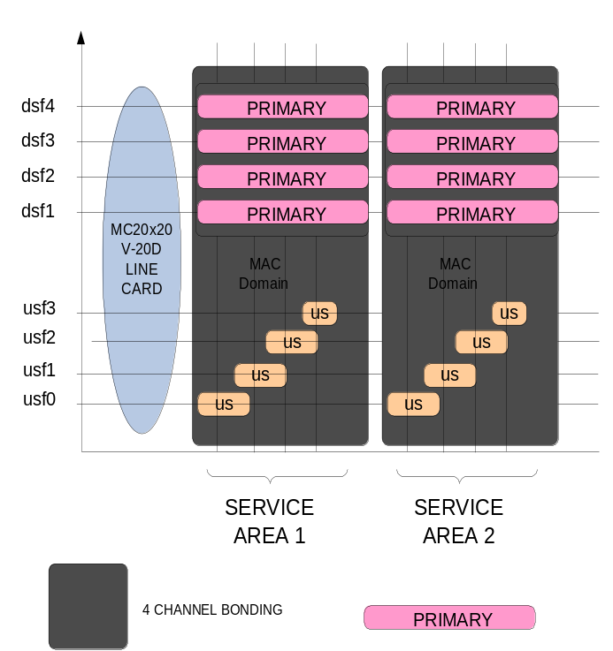

controller integrated-cable 8/1/0
rf-channel 0 cable downstream channel-id 80
rf-channel 0 frequency 453000000 annex B modulation 256qam interleave 32
no rf-channel 0 rf-shutdown
rf-channel 1 cable downstream channel-id 81
rf-channel 1 frequency 459000000 annex B modulation 256qam interleave 32
no rf-channel 1 rf-shutdown
rf-channel 2 cable downstream channel-id 82
rf-channel 2 frequency 465000000 annex B modulation 256qam interleave 32
no rf-channel 2 rf-shutdown
rf-channel 3 cable downstream channel-id 83
rf-channel 3 frequency 471000000 annex B modulation 256qam interleave 32
no rf-channel 3 rf-shutdown

controller Integrated-Cable 8/1/1
rf-channel 0 cable downstream channel-id 84
rf-channel 0 frequency 453000000 annex B modulation 256qam interleave 32
no rf-channel 0 rf-shutdown
rf-channel 1 cable downstream channel-id 85
rf-channel 1 frequency 459000000 annex B modulation 256qam interleave 32
no rf-channel 1 rf-shutdown
rf-channel 2 cable downstream channel-id 86
rf-channel 2 frequency 465000000 annex B modulation 256qam interleave 32
no rf-channel 2 rf-shutdown
rf-channel 3 cable downstream channel-id 87
rf-channel 3 frequency 471000000 annex B modulation 256qam interleave 32
no rf-channel 3 rf-shutdown

controller Integrated-Cable 8/1/2
!as above but for incrementing channel-id

controller Integrated-Cable 8/1/3
!as above but for incrementing channel-id

controller Integrated-Cable 8/1/4
!as above but for incrementing channel-id

interface cable8/1/0
! define the primary capable downstream
downstream integrated-cable 8/1/0:0
downstream integrated-cable 8/1/0:1
downstream integrated-cable 8/1/0:2
downstream integrated-cable 8/1/0:3
!
! set up the upstream bonding
!
cable upstream max-ports 4
cable upstream bonding-group 1
upstream 0
upstream 1
upstream 2
upstream 3
attributes 800000AB
cable upstream resiliency channel-down-detect 32
!
cable upstream 0 connector 0
cable upstream 0 frequency 14600000
cable upstream 0 channel-width 6400000 6400000
cable upstream 0 load-balance group 1
cable upstream 0 docsis-mode atdma
cable upstream 0 minislot-size 1
cable upstream 0 range-backoff 3 6
cable upstream 0 modulation-profile 224 225 226
cable upstream 0 attribute-mask AB
no cable upstream 0 shutdown
!
cable upstream 1 connector 1
cable upstream 1 frequency 21000000
cable upstream 1 channel-width 6400000 6400000
cable upstream 1 load-balance group 1
cable upstream 1 docsis-mode atdma
cable upstream 1 minislot-size 1
cable upstream 1 range-backoff 3 6
cable upstream 1 modulation-profile 224 225 226
cable upstream 1 attribute-mask AB
no cable upstream 1 shutdown

!
cable upstream 2 connector 2
cable upstream 2 frequency 27400000
cable upstream 2 channel-width 6400000 6400000
cable upstream 2 load-balance group 1
cable upstream 2 docsis-mode atdma
cable upstream 2 minislot-size 1
cable upstream 2 range-backoff 3 6
cable upstream 2 modulation-profile 224 225 226
cable upstream 2 attribute-mask AB
no cable upstream 2 shutdown

!
cable upstream 3 connector 3
cable upstream 3 frequency 33800000
cable upstream 3 channel-width 3200000 3200000
cable upstream 3 load-balance group 1
cable upstream 3 docsis-mode tdma-atdma
cable upstream 3 minislot-size 2
cable upstream 3 range-backoff 3 6
cable upstream 3 modulation-profile 124 125 126
cable upstream 3 attribute-mask AB
no cable upstream 3 shutdown
!
cable sid-cluster-switching max-request 0
cable sid-cluster-switching max-outstanding-byte 0
cable sid-cluster-switching max-total-byte 0
cable sid-cluster-switching max-time 0
Future → Need to detail what is happening here
0 is the default condition though
!
interface cable8/1/1
! as above but upstream number incrementing
!
interface cable8/1/2
! as above but upstream number incrementing
!
interface cable8/1/3
! as above but upstream number incrementing
!
interface cable8/1/4
! as above but upstream number incrementing

interface Wideband-Cable8/1/0:0
cable bonding-group-id 1377
cable rf-channel 0
cable rf-channel 1
cable rf-channel 2
cable rf-channel 3
cable downstream attribute-mask 800000AB
Future → Detail why attribute mask being set

!
interface Wideband-Cable8/1/1:0
cable bonding-group-id 1378
cable rf-channel 0
cable rf-channel 1
cable rf-channel 2
cable rf-channel 3
cable downstream attribute-mask 800000AB
!
interface Wideband-Cable8/1/2:0
! as above but incrementing the bonding-group-id
!
interface Wideband-Cable8/1/3:0
! as above but incrementing the bonding-group-id
!
interface Wideband-Cable8/1/4:0
! as above but incrementing the bonding-group-id

cable fiber-node 1
description Serving Area 1
downstream Integrated-Cable 8/1/0 rf-channel 0-3
upstream Cable 8/1 connector 0-3
!
cable fiber-node 2
description Serving Area 2
downstream Integrated-Cable 8/1/1 rf-channel 0-3
upstream Cable 8/1 connector 4-7
!
cable fiber-node 3
description Serving Area 3
downstream Integrated-Cable 8/1/1 rf-channel 0-3
upstream Cable 8/1 connector 8-11
!
cable fiber-node 4
description Serving Area 4
downstream Integrated-Cable 8/1/1 rf-channel 0-3
upstream Cable 8/1 connector 12-15
!
cable fiber-node 5
description Serving Area 5
downstream Integrated-Cable 8/1/1 rf-channel 0-3
upstream Cable 8/1 connector 16-19

Shared (spanned) 8 channel bonding into 4 service areas
This example shows how to allocate downstream from a controller to a bonding group in more than one MAC domain.
This makes the 20 downstream line card “look like” a 32 downstream line card and provides increased peak bandwidth in each downstream service area but ultimately the sustained throughput is that of a 20 downstream line card
This example can be used to inject the same multicast traffic into the 4 service areas without multicast replication being required.
WARNING: If the modem does not see contiguous 8 channels it will not come w-online without you defining a custom RCP in the CMTS.

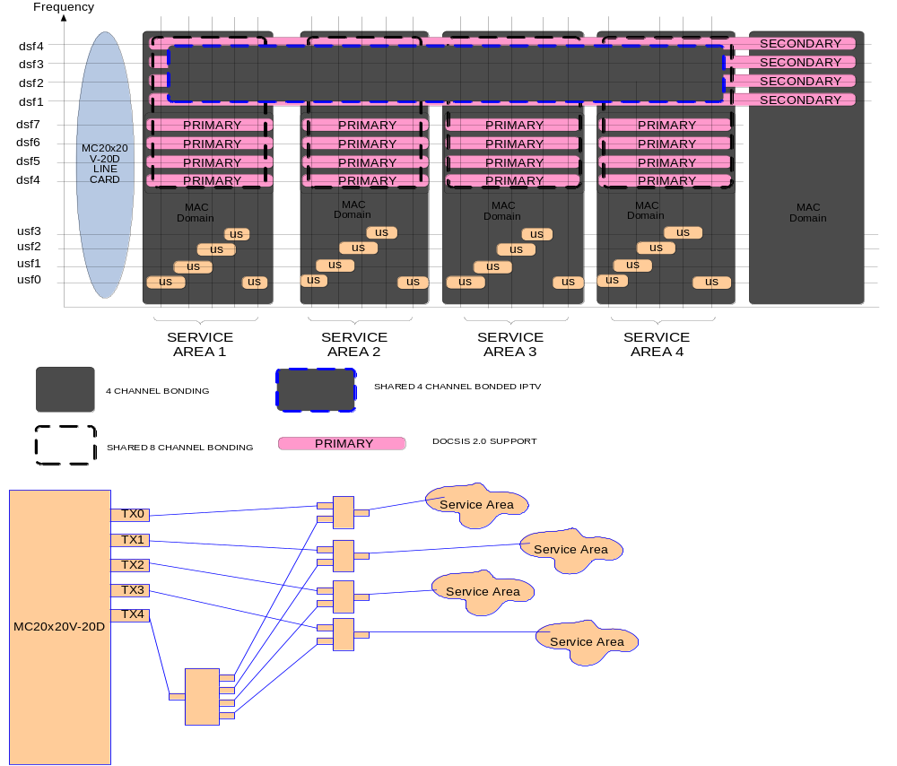

controller integrated-cable 8/1/0
rf-channel 0 cable downstream channel-id 80
rf-channel 0 frequency 453000000 annex B modulation 256qam interleave 32
no rf-channel 0 rf-shutdown
rf-channel 1 cable downstream channel-id 81
rf-channel 1 frequency 459000000 annex B modulation 256qam interleave 32
no rf-channel 1 rf-shutdown
rf-channel 2 cable downstream channel-id 82
rf-channel 2 frequency 465000000 annex B modulation 256qam interleave 32
no rf-channel 2 rf-shutdown
rf-channel 3 cable downstream channel-id 83
rf-channel 3 frequency 471000000 annex B modulation 256qam interleave 32
no rf-channel 3 rf-shutdown

controller Integrated-Cable 8/1/1
rf-channel 0 cable downstream channel-id 84
rf-channel 0 frequency 453000000 annex B modulation 256qam interleave 32
no rf-channel 0 rf-shutdown
rf-channel 1 cable downstream channel-id 85
rf-channel 1 frequency 459000000 annex B modulation 256qam interleave 32
no rf-channel 1 rf-shutdown
rf-channel 2 cable downstream channel-id 86
rf-channel 2 frequency 465000000 annex B modulation 256qam interleave 32
no rf-channel 2 rf-shutdown
rf-channel 3 cable downstream channel-id 87
rf-channel 3 frequency 471000000 annex B modulation 256qam interleave 32
no rf-channel 3 rf-shutdown

controller Integrated-Cable 8/1/2
!as above but for incrementing channel-id

controller Integrated-Cable 8/1/3
!as above but for incrementing channel-id

controller Integrated-Cable 8/1/4
!as above but for incrementing channel-id

interface cable8/1/0
! define the primary capable downstream
downstream integrated-cable 8/1/0:0
downstream integrated-cable 8/1/0:1
downstream integrated-cable 8/1/0:2
downstream integrated-cable 8/1/0:3
!
cable upstream max-ports 5
cable upstream bonding-group 1
upstream 0
upstream 1
upstream 2
upstream 3
attributes 800000AB
cable upstream resiliency channel-down-detect 32
!
cable upstream 0 connector 0
cable upstream 0 frequency 14600000
cable upstream 0 channel-width 6400000 6400000
cable upstream 0 load-balance group 1
cable upstream 0 docsis-mode atdma
cable upstream 0 minislot-size 1
cable upstream 0 range-backoff 3 6
cable upstream 0 modulation-profile 224 225 226
cable upstream 0 attribute-mask AB
no cable upstream 0 shutdown
!
cable upstream 1 connector 1
cable upstream 1 frequency 21000000
cable upstream 1 channel-width 6400000 6400000
cable upstream 1 load-balance group 1
cable upstream 1 docsis-mode atdma
cable upstream 1 minislot-size 1
cable upstream 1 range-backoff 3 6
cable upstream 1 modulation-profile 224 225 226
cable upstream 1 attribute-mask AB
no cable upstream 1 shutdown

!
cable upstream 2 connector 2
cable upstream 2 frequency 27400000
cable upstream 2 channel-width 6400000 6400000
cable upstream 2 load-balance group 1
cable upstream 2 docsis-mode atdma
cable upstream 2 minislot-size 1
cable upstream 2 range-backoff 3 6
cable upstream 2 modulation-profile 224 225 226
cable upstream 2 attribute-mask AB
no cable upstream 2 shutdown

!
cable upstream 3 connector 3
cable upstream 3 frequency 33800000
cable upstream 3 channel-width 3200000 3200000
cable upstream 3 load-balance group 1
cable upstream 3 docsis-mode tdma-atdma
cable upstream 3 minislot-size 2
cable upstream 3 range-backoff 3 6
cable upstream 3 modulation-profile 124 125 126
cable upstream 3 attribute-mask AB
no cable upstream 3 shutdown
!
cable upstream 4 connector 4
cable upstream 4 frequency 37000000
cable upstream 4 channel-width 3200000 3200000
cable upstream 4 load-balance group 1
cable upstream 4 docsis-mode tdma-atdma
cable upstream 4 minislot-size 2
cable upstream 4 range-backoff 3 6
cable upstream 4 modulation-profile 124 125 126
cable upstream 4 attribute-mask AB
no cable upstream 4 shutdown
!
cable sid-cluster-switching max-request 0
cable sid-cluster-switching max-outstanding-byte 0
cable sid-cluster-switching max-total-byte 0
cable sid-cluster-switching max-time 0
!
interface cable8/1/1
! as above but upstream number incrementing
!
interface cable8/1/2
! as above but upstream number incrementing
!
interface cable8/1/3
! as above but upstream number incrementing
!

interface integrated-cable 8/1/0:0
description ** narrowband modems here
cable bundle 1
cable dynamic-bw-sharing
! this is a primary downstream and at least 4% needed for primary operation
cable rf-bandwidth-percent 4
!
interface Integrated-Cable 8/1/0:1
description ** narrowband modems here
cable bundle 1
cable dynamic-bw-sharing
! this is a primary downstream and at least 4% needed for primary operation
cable rf-bandwidth-percent 4
!
interface Integrated-Cable 8/1/0:2
description ** narrowband modems here
cable bundle 1
cable dynamic-bw-sharing
! this is a primary downstream and at least 4% needed for primary operation
cable rf-bandwidth-percent 4
!
interface Integrated-Cable 8/1/0:3
description ** narrowband modems here
cable bundle 1
cable dynamic-bw-sharing
! this is a primary downstream and at least 4% needed for primary operation
cable rf-bandwidth-percent 4
!

interface Wideband-Cable8/1/0:0
cable bonding-group-id 1377
cable dynamic-bw-sharing
cable rf-channel 0 bandwidth-percent 1
cable rf-channel 1 bandwidth-percent 1
cable rf-channel 2 bandwidth-percent 1
cable rf-channel 3 bandwidth-percent 1
cable rf-channel controller 4 channel 0 bandwidth-percent 1
cable rf-channel controller 4 channel 1 bandwidth-percent 1
cable rf-channel controller 4 channel 2 bandwidth-percent 1
cable rf-channel controller 4 channel 3 bandwidth-percent 1
cable downstream attribute-mask 800000AB

!
interface Wideband-Cable8/1/1:0
cable bonding-group-id 1378
cable dynamic-bw-sharing
cable rf-channel 0 bandwidth-percent 1
cable rf-channel 1 bandwidth-percent 1
cable rf-channel 2 bandwidth-percent 1
cable rf-channel 3 bandwidth-percent 1
cable rf-channel controller 4 channel 0 bandwidth-percent 1
cable rf-channel controller 4 channel 1 bandwidth-percent 1
cable rf-channel controller 4 channel 2 bandwidth-percent 1
cable rf-channel controller 4 channel 3 bandwidth-percent 1
cable downstream attribute-mask 800000AB
!
interface Wideband-Cable8/1/2:0
! as above but incrementing the bonding-group-id
!
interface Wideband-Cable8/1/3:0
! as above but incrementing the bonding-group-id
!

interface Wideband-Cable8/1/4:0
! this wideband group used for shared multicast traffic
! with 20 percent reserved for such mcast traffic
! NOTE: The RF channels used for secondary bonding groups are non-primary capable
! Reference [2]
cable bonding-group-id 1381 secondary
cable dynamic-bw-sharing
cable rf-channel controller 4 channel 0 bandwidth-percent 20
cable rf-channel controller 4 channel 1 bandwidth-percent 20
cable rf-channel controller 4 channel 2 bandwidth-percent 20
cable rf-channel controller 4 channel 3 bandwidth-percent 20

cable fiber-node 1
description Serving Area 1
downstream integrated-cable 8/1/0 rf-channel 0-3
downstream integrated-cable 8/1/4 rf-channel 0-3
upstream Cable 8/1 connector 0-3
!
cable fiber-node 2
description Serving Area 2
downstream Integrated-Cable 8/1/1 rf-channel 0-3
downstream integrated-cable 8/1/4 rf-channel 0-3
upstream Cable 8/1 connector 4-7
!
cable fiber-node 3
description Serving Area 3
downstream Integrated-Cable 8/1/2 rf-channel 0-3
downstream integrated-cable 8/1/4 rf-channel 0-3
upstream Cable 8/1 connector 8-11
!
cable fiber-node 4
description Serving Area 4
downstream Integrated-Cable 8/1/3 rf-channel 0-3
downstream integrated-cable 8/1/4 rf-channel 0-3
upstream Cable 8/1 connector 12-15
!

Shared (spanned) 4 channel IPTV into 4 service areas
This example shows how to use the downstream from a controller to provide static linear (broadcast) IPTV into the 4 service areas supported by the line card,
This makes the 20 downstream line card “look like” a 32 downstream line card.
WARNING: If the modem does not see contiguous 8 channels it will not come w-online without you defining a custom RCP in the CMTS.

Basic Multicast Forwarding
Please note that these commands are required to have CMTS forwarding Multicast packets. However, Multicast QoS, BPI+, Authorization features are all optional for multicast packets to be forwarded correctly.

Global Configuration Commands:
ip multicast-routing
ip multicast-routing [vrf]

Interface Configuration Commands:
Cable Interface:
ip pim sparse-mode
ip igmp version 3

Gigabit Interface:
ip pim sparse-dense-mode

Configuration Example:
ip multicast-routing

int g1/0/0
ip pim sparse-dense-mode
int Bundle 1
ip pim sparse-mode
ip igmp version 3

Show Commands:
show ip mroute
show cable bundle [bundle ID] multicast
show cable bundle [bundle ID] forwarding
show pxf cpu mroute [group]
show pxf cable multicast [group]

Multicast DSID Forwarding

Configuration Commands:
Multicast DSID Forwarding is enabled all the time and cannot be disabled.

Show Commands:
show cable multicast dsid
show cable modem [mac/ip] verbose

to display if a CM is MDF-enabled

Explicit Tracking

Configuration Commands:
Explicit Tracking is enabled all the time and cannot be disabled.

Show commands:
show cable multicast db

Multicast QoS

Users are required to define 3 objects/templates and then associate these to a particular bundle or forwarding interface. The objects are Service-Class, Group-QoS-Config(GQC), and Group-Config(GC). Please note that a default service class and GQC must be defined beforehand.

cable match address CLI has been deprecated and will not be allowed during runtime. However, CMTS will accept this command on startup-config and auto-upgrade into new CLI.

Global Configuration Commands:

Service Class:
cable service class 1 name [service class name]
cable service class 1 downstream
cable service class 1 max-rate [maximum bandwidth allowed]
cable service class 1 min-rate [cir]

Group-QoS-Config (GQC):
cable multicast group-qos default scn [service class name] aggregate
cable multicast group-qos [gqc-id] scn [service class name]
[aggregate/single] [session limit – if aggregate]
[override – if session limit configured]

Group-Config (GC):
cable multicast qos group [gc-id] priority [GC priority]
application-id [app-id]
session-range [group] [group-mask] [source] [source-mask]
tos [tos value]
vrf [vrf name]
group-qos [gqc-id]
end

Associating the Group-Config(GC) into Bundle or forwarding interface:

For what we want to do we can statically assign the multicast to the specific 4 channel bonded (spanned) downstream.

If we wanted to have dynamic multicast assignment we would have to use service attributes to define the multicast bonded downstream that would be used to forward the multicast.

Interface Configuration Commands:
cable multicast-qos group [gc-id]

Configuration Example:
cable service class 1 name MQOS_DEFAULT
cable service class 1 downstream
cable service class 1 max-rate 10000000
cable service class 1 min-rate 1000000
cable service class 2 name MQOS
cable service class 2 downstream
cable service class 2 max-rate 8000000
cable service class 2 min-rate 2000000

cable multicast group-qos default scn MQOS_DEFAULT aggregate
cable multicast group-qos 10 scn MQOS single

cable multicast qos group 20 priority 1
! assign all Mcast to this group
session-range 230.0.0.0 255.0.0.0
group-qos 10

interface Cable5/0/0
! we would assign to the wideband interface
! being used for the spanned IPTV
Action → update this to reflect a wideband interface
cable multicast-qos group 20

Show Commands:
show cable multicast qos
show interface [forwarding interface] multicast-session
show interface [interface] service-flow
show pxf cpu queue [forwarding interface]

Multicast BPI+

Important: Encrypted multicast over spanned downstream is NOT supported. This section is included for completeness only:

Multicast BPI+ basically reuses the Multicast QoS CLI model, under Group-Config(GC) object.

cable match address CLI has been deprecated and will not be allowed during runtime. However, CMTS will accept this command on startup-config and auto-upgrade into new CLI.

Global Configuration Commands:
cable multicast group-encryption [group-encrypt-id] algorithm 56bit-des

cable multicast qos group [gc-id] priority [gc priority]
session-range [group] [group-mask] [source] [source-mask]
group-encryption [group-encrypt-id]

Interface Configuration Commands:
cable multicast-qos group [gc-id]

Configuration Example:
cable multicast group-encryption 30 algorithm 56bit-des

cable multicast qos group 40 priority 2
session-range 230.0.0.0 255.0.0.0
group-encryption 30

interface Cable5/0/0
cable multicast-qos group 40

Show Commands:
Show interface [forwarding interface] multicast-session
Show interface [interface] key sid 0

Multicast Authorization

The Authorization is disabled by default and user is required to enable and configure this properly.

Global Configuration Commands:
Enable this feature globally:
cable multicast authorization enable default [default action- permit/deny] max-sessions [limit]

Configure authorization profiles and rules:
cable multicast authorization profile [profile-name]
Match rule [ipv4/ipv6] [source prefix] [group prefix]
priority [rule-priority] [action-permit/deny]

Configuration Example:
cable multicast auth enable default-action deny max-sessions 10

cable multicast auth profile GOLD
match rule ipv4 source 0.0.0.0/0 230.0.0.0/16 128 permit
match rule ipv4 source 10.1.1.1/8 232.0.0.0/8 128 permit
end

CM Configuration is required to define with correct profile name, in this example, “GOLD”.

Show Commands:
show cable multicast authorization
show cable modem [mac/ip] verbose
Display the associated profile and session limit for a CM

Static Multicast Session
This feature is always enabled and depending on CM Configuration file. Users can use Show CLI to display the DSID for a particular session and CM from explicit tracking database.

Show Commands:
show cable multicast dsid
show cable multicast db

VIDEO server:
A suitable video server can be built using the VLC server/client application in a Windows XP or Linux environment.
The past demonstrations have used a Lenovo T61 laptop and is capable of generating 5 standard definition video streams.
The VLC server can be downloaded from:
http://www.videolan.org

Modify the batch file embedded following including vlc path, video file name and multicast address so that one-click can start the streaming
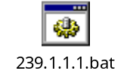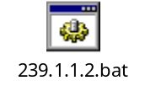

UBR10012 configuration sample 1 (VDOC)

At present this is just a CLI listing of the running config THAT DOES NOT USE THE MC20x20V with relevant sections highlighted.
Future → to be updated for MC20x20V configuration

Yellow is the CLI for VDOC.
http://www.cisco.com/en/US/docs/ios/cable/configuration/guide/VDOC_dbc_feature.html

Green is the CLI for MQoS.
http://www.cisco.com/en/US/docs/ios/cable/configuration/guide/ubr_d30_mcast_support.html#wp1083525

uBR10K#
uBR10K#
uBR10K#sh run
Building configuration...

Current configuration : 21095 bytes
!
! Last configuration change at 11:16:09 UTC Sun Apr 1 2001
! NVRAM config last updated at 14:58:55 UTC Sun Apr 1 2001
!
version 12.2
no service pad
service timestamps debug datetime msec localtime
service timestamps log datetime msec localtime
no service password-encryption
!
hostname uBR10K
!
boot-start-marker
boot system flash disk0:ubr10k2-k9p6u2-mz.122-33.SCB.bin
boot-end-marker
!
logging buffered 1000000 informational
enable password cisco
!
no aaa new-model
clock calendar-valid
facility-alarm core-temperature major 58
facility-alarm core-temperature minor 50
facility-alarm intake-temperature major 54
facility-alarm intake-temperature minor 45
!
!
cr10k-rp card 5/0 oir-compatibility
cr10k-rp card 6/1 oir-compatibility
card 1 2jacket-1
card 1/0 24rfchannel-spa-1
card 1/1 2cable-dtcc
card 2/1 2cable-dtcc
card 4/0 1gigethernet-hh-1
card 4/1 1gigethernet-hh-1
card 6/1 5cable-mc520h-d
cable admission-control preempt priority-voice
cable modem remote-query 10 public
cable modem vendor 00.17.EE "Motorola"
cable modem vendor 00.18.68 "SA"
cable modem vendor 00.16.92 "SA"
cable modem vendor 00.40.7B "SA"
cable modem vendor 00.1A.C3 "Cisco"
cable modem vendor 00.14.E8 "Motorola"
cable modem vendor 00.21.43 "Motorola"
cable modem vendor 00.1F.C4 "Motorola"
cable modulation-profile 222 request 0 16 0 22 64qam scrambler 152 no-diff 64 fixed qpsk1 1 2048
cable modulation-profile 222 initial 5 34 0 48 64qam scrambler 152 no-diff 128 fixed qpsk1 1 2048
cable modulation-profile 222 station 5 34 0 48 64qam scrambler 152 no-diff 128 fixed qpsk1 1 2048
cable modulation-profile 222 a-short 6 76 6 22 64qam scrambler 152 no-diff 64 shortened qpsk1 1 2048
cable modulation-profile 222 a-long 9 232 0 22 64qam scrambler 152 no-diff 64 shortened qpsk1 1 2048
cable modulation-profile 222 a-ugs 9 232 0 22 64qam scrambler 152 no-diff 64 shortened qpsk1 1 2048
cable modulation-profile 223 request 0 16 0 22 64qam scrambler 152 no-diff 64 fixed qpsk1 1 2048
cable modulation-profile 223 initial 5 34 0 48 64qam scrambler 152 no-diff 128 fixed qpsk1 1 2048
cable modulation-profile 223 station 5 34 0 48 64qam scrambler 152 no-diff 128 fixed qpsk1 1 2048
cable modulation-profile 223 a-short 6 76 6 22 64qam scrambler 152 no-diff 64 shortened qpsk1 1 2048
cable modulation-profile 223 a-long 9 232 0 22 64qam scrambler 152 no-diff 64 shortened qpsk1 1 2048
cable modulation-profile 223 a-ugs 9 232 0 22 64qam scrambler 152 no-diff 64 shortened qpsk1 1 2048
cable modulation-profile 224 request 0 16 0 22 16qam scrambler 152 no-diff 32 fixed qpsk1 1 2048
cable modulation-profile 224 initial 5 34 0 48 16qam scrambler 152 no-diff 64 fixed qpsk1 1 2048
cable modulation-profile 224 station 5 34 0 48 16qam scrambler 152 no-diff 64 fixed qpsk1 1 2048
cable modulation-profile 224 a-short 4 76 7 22 16qam scrambler 152 no-diff 64 shortened qpsk1 1 2048
cable modulation-profile 224 a-long 9 232 0 22 16qam scrambler 152 no-diff 64 shortened qpsk1 1 2048
cable modulation-profile 224 a-ugs 9 232 0 22 16qam scrambler 152 no-diff 64 shortened qpsk1 1 2048
cable service class 1 name def_sclass
cable service class 1 downstream
cable service class 1 max-rate 10000000
cable service class 1 min-rate 0
cable service class 5 name MQoS
cable service class 5 downstream
cable service class 5 max-rate 38000000
cable service class 5 max-burst 250000
cable service class 5 min-rate 10000000
cable service class 5 priority 4
cable service attribute ds-bonded downstream-type bonding-enabled
no cable qos permission create
no cable qos permission update
cable qos permission modems
cable multicast group-qos default scn def_sclass aggregate
cable multicast group-qos 1 scn MQoS aggregate
cable multicast group-qos 5 scn MQoS aggregate
!
cable multicast qos group 1 priority 1
session-range 225.0.0.0 255.0.0.0
group-qos 1
!
cable multicast qos group 5 priority 5
session-range 239.1.1.0 255.255.255.0
session-range 225.1.1.0 255.255.255.0
group-qos 5
!
cable time-server
cable throttle-ranging
cable diaglog active
cable load-balance group 1 method utilization
cable load-balance group 1 interval 30
cable load-balance group 1 dcc-init-technique 1
cable load-balance group 1 threshold load 10 enforce 18
cable load-balance group 20 method utilization
cable load-balance group 20 interval 30
cable load-balance group 20 dcc-init-technique 1
cable load-balance group 20 threshold load 10 enforce 22
cable load-balance group 20 policy us-groups-across-ds
cable load-balance exclude modem 00e0.6f72.84b0 strict
cable load-balance exclude modem 00e0.6f86.4aaa strict
cable load-balance exclude modem 00e0.6fdc.981c strict
cable load-balance exclude oui 00.21.43
cable load-balance exclude oui 00.1A.C3
cable clock dti
cable wideband auto-reset
!
cable rcc-template 1
rcp-id 00 10 18 33 81
receive-module 1 first-center-frequency 609000000
receive-channel 1 center-frequency 609000000 connected-receive-module 1 primary
receive-channel 2 center-frequency 615000000 connected-receive-module 1
receive-channel 3 center-frequency 621000000 connected-receive-module 1
!
cable rcc-template 2
rcp-id 00 10 18 33 81
receive-module 1 first-center-frequency 609000000
receive-channel 1 center-frequency 609000000 connected-receive-module 1 primary
receive-channel 2 center-frequency 615000000 connected-receive-module 1
receive-channel 3 center-frequency 627000000 connected-receive-module 1
!
cable rcc-template 3
rcp-id 00 10 18 33 81
receive-module 1 first-center-frequency 609000000
receive-channel 1 center-frequency 609000000 connected-receive-module 1 primary
receive-channel 2 center-frequency 615000000 connected-receive-module 1
receive-channel 3 center-frequency 633000000 connected-receive-module 1
!
cable rcc-template 4
rcp-id 00 10 00 00 03
receive-module 1 first-center-frequency 639000000
receive-channel 1 center-frequency 639000000 connected-receive-module 1 primary
receive-channel 2 center-frequency 645000000 connected-receive-module 1
receive-channel 3 center-frequency 651000000 connected-receive-module 1
receive-channel 4 center-frequency 657000000 connected-receive-module 1
!
ip subnet-zero
no ip domain lookup
ip multicast-routing
ip dhcp relay information option
no ip dhcp use vrf connected
ip dhcp excluded-address 10.10.152.1
ip dhcp excluded-address 61.18.187.1
!
ip dhcp pool management
network 192.168.9.0 255.255.255.0
default-router 192.168.9.2
!
ip dhcp pool pc
network 61.18.187.0 255.255.255.0
next-server 61.18.187.1
default-router 61.18.187.1
domain-name cisco.com
dns-server 61.18.187.1
lease 7 0 10
!
ip dhcp pool cm
network 10.10.152.0 255.255.248.0
bootfile basic30.cfg
next-server 10.10.152.1
option 2 hex ffff.b9b0
default-router 10.10.152.1
option 7 ip 10.10.152.1
option 4 ip 10.10.152.1
lease 5
!
!
!
!
!
!
!
redundancy
mode sso
!
ip access-list extended mqosacl
permit ip any 225.0.0.0 0.255.255.255
!
controller Modular-Cable 1/0/0
ip-address 192.168.200.45
modular-host subslot 6/1
rf-channel 0 cable downstream channel-id 24
rf-channel 0 frequency 609000000 annex B modulation 256qam interleave 32
rf-channel 0 ip-address 192.168.200.40 mac-address 0050.4b11.3930 depi-remote-id 37001
rf-channel 1 cable downstream channel-id 25
rf-channel 1 frequency 615000000 annex B modulation 256qam interleave 32
rf-channel 1 ip-address 192.168.200.40 mac-address 0050.4b11.3930 depi-remote-id 37002
rf-channel 2 cable downstream channel-id 26
rf-channel 2 frequency 621000000 annex B modulation 256qam interleave 32
rf-channel 2 ip-address 192.168.200.40 mac-address 0050.4b11.3930 depi-remote-id 37003
rf-channel 3 cable downstream channel-id 27
rf-channel 3 frequency 627000000 annex B modulation 256qam interleave 32
rf-channel 3 ip-address 192.168.200.40 mac-address 0050.4b11.3930 depi-remote-id 37004
rf-channel 4 cable downstream channel-id 28
rf-channel 4 frequency 633000000 annex B modulation 256qam interleave 32
rf-channel 4 ip-address 192.168.200.40 mac-address 0050.4b11.3930 depi-remote-id 37005
rf-channel 5 cable downstream channel-id 29
rf-channel 5 frequency 639000000 annex B modulation 256qam interleave 32
rf-channel 5 ip-address 192.168.200.40 mac-address 0050.4b11.3930 depi-remote-id 37006
rf-channel 6 cable downstream channel-id 30
rf-channel 6 frequency 645000000 annex B modulation 256qam interleave 32
rf-channel 6 ip-address 192.168.200.40 mac-address 0050.4b11.3930 depi-remote-id 37007
rf-channel 7 cable downstream channel-id 31
rf-channel 7 frequency 651000000 annex B modulation 256qam interleave 32
rf-channel 7 ip-address 192.168.200.40 mac-address 0050.4b11.3930 depi-remote-id 37008
rf-channel 8 cable downstream channel-id 32
rf-channel 8 frequency 657000000 annex B modulation 256qam interleave 32
rf-channel 8 ip-address 192.168.200.40 mac-address 0050.4b11.3930 depi-remote-id 37009
rf-channel 9 cable downstream channel-id 33
rf-channel 10 cable downstream channel-id 34
rf-channel 11 cable downstream channel-id 35
rf-channel 12 cable downstream channel-id 36
rf-channel 13 cable downstream channel-id 37
rf-channel 14 cable downstream channel-id 38
rf-channel 15 cable downstream channel-id 39
rf-channel 16 cable downstream channel-id 40
rf-channel 17 cable downstream channel-id 41
rf-channel 18 cable downstream channel-id 42
rf-channel 19 cable downstream channel-id 43
rf-channel 20 cable downstream channel-id 44
rf-channel 21 cable downstream channel-id 45
rf-channel 22 cable downstream channel-id 46
rf-channel 23 cable downstream channel-id 47
!
!
!
!
!
!
interface Loopback0
ip address 10.1.1.1 255.255.255.255
!
interface FastEthernet0/0/0
ip address 192.168.9.2 255.255.255.0
load-interval 30
speed auto
duplex auto
!
interface Wideband-Cable1/0/0:0
load-interval 30
cable bundle 1
cable bonding-group-id 1
cable rf-channel 0 bandwidth-percent 95
cable rf-channel 1
!
interface Wideband-Cable1/0/0:1
load-interval 30
cable bundle 1
cable igmp static-group 239.1.1.1
cable igmp static-group 239.1.1.7
cable igmp static-group 239.1.1.8
cable bonding-group-id 2 secondary
cable rf-channel 2
!
interface Wideband-Cable1/0/0:2
load-interval 30
cable bundle 1
cable igmp static-group 239.1.1.3
cable igmp static-group 239.1.1.4
cable bonding-group-id 3 secondary
cable rf-channel 3
!
interface Wideband-Cable1/0/0:3
load-interval 30
cable bundle 1
cable igmp static-group 239.1.1.5
cable igmp static-group 239.1.1.6
cable bonding-group-id 4 secondary
cable rf-channel 4
!
interface Wideband-Cable1/0/0:4
load-interval 30
cable bundle 1
cable bonding-group-id 5
cable rf-channel 5 bandwidth-percent 95
cable rf-channel 6
cable rf-channel 7
cable rf-channel 8
!
interface Wideband-Cable1/0/0:5
cable bonding-group-id 6
!
interface Wideband-Cable1/0/0:6
cable bonding-group-id 7
!
interface Wideband-Cable1/0/0:7
cable bonding-group-id 8
!
interface Wideband-Cable1/0/0:8
cable bonding-group-id 9
!
interface Wideband-Cable1/0/0:9
cable bonding-group-id 33
!
interface Wideband-Cable1/0/0:10
cable bonding-group-id 34
!
interface Wideband-Cable1/0/0:11
cable bonding-group-id 35
!
interface Modular-Cable1/0/0:0
load-interval 30
cable bundle 1
cable rf-bandwidth-percent 1
cable cm-status enable 1-2 4-5
!
interface Modular-Cable1/0/0:1
load-interval 30
cable bundle 1
no cable rf-bandwidth-percent
cable cm-status enable 1-2 4-5
!
interface Modular-Cable1/0/0:2
load-interval 30
cable bundle 1
no cable rf-bandwidth-percent
cable cm-status enable 1-2 4-5
!
interface Modular-Cable1/0/0:3
load-interval 30
cable bundle 1
no cable rf-bandwidth-percent
cable cm-status enable 1-2 4-5
!
interface Modular-Cable1/0/0:4
load-interval 30
cable bundle 1
no cable rf-bandwidth-percent
cable cm-status enable 1-2 4-5
!
interface Modular-Cable1/0/0:5
load-interval 30
cable bundle 1
cable rf-bandwidth-percent 1
cable cm-status enable 1-2 4-5
!
interface Modular-Cable1/0/0:6
cable bundle 1
no cable rf-bandwidth-percent
no cable cm-status enable 1-2 4-5
!
interface Modular-Cable1/0/0:7
load-interval 30
cable bundle 1
no cable rf-bandwidth-percent
cable cm-status enable 1-2 4-5
!
interface Modular-Cable1/0/0:8
load-interval 30
cable bundle 1
no cable rf-bandwidth-percent
cable cm-status enable 1-2 4-5
!
interface GigabitEthernet4/0/0
ip address 10.254.9.52 255.255.255.192
ip pim sparse-mode
ip ospf priority 0
load-interval 30
negotiation auto
!
interface GigabitEthernet4/1/0
no ip address
negotiation auto
!
interface Cable6/1/0
load-interval 30
downstream local upstream 0
downstream Modular-Cable 1/0/0 rf-channel 0-8
cable rcc-template 3
cable rcc-template 2
cable rcc-template 1
cable rcc-template 4
cable cm-status enable 1-2 4-5
no cable packet-cache
cable default-phy-burst 0
cable map-advance dynamic 600 600
cable bundle 1
cable downstream channel-id 148
cable downstream annex B
cable downstream modulation 256qam
cable downstream interleave-depth 32
cable downstream frequency 657000000
cable downstream rf-shutdown
cable upstream max-ports 4
cable upstream 0 connector 0
cable upstream 0 frequency 20200000
cable upstream 0 docsis-mode atdma
cable upstream 0 channel-width 6400000 6400000
cable upstream 0 minislot-size 2
cable upstream 0 power-level 5
cable upstream 0 fragment-force 2000
cable upstream 0 range-backoff 3 6
cable upstream 0 modulation-profile 221
no cable upstream 0 shutdown
cable upstream 1 connector 1
cable upstream 1 frequency 26600000
cable upstream 1 docsis-mode atdma
cable upstream 1 channel-width 6400000 6400000
cable upstream 1 minislot-size 1
cable upstream 1 power-level 5
cable upstream 1 range-backoff 3 6
cable upstream 1 modulation-profile 221
cable upstream 1 load-balance group 1
cable upstream 1 shutdown
cable upstream 2 connector 2
cable upstream 2 docsis-mode tdma
cable upstream 2 channel-width 1600000 1600000
cable upstream 2 minislot-size 4
cable upstream 2 range-backoff 3 6
cable upstream 2 modulation-profile 21
cable upstream 2 shutdown
cable upstream 3 connector 3
cable upstream 3 docsis-mode tdma
cable upstream 3 channel-width 1600000 1600000
cable upstream 3 minislot-size 4
cable upstream 3 range-backoff 3 6
cable upstream 3 modulation-profile 21
cable upstream 3 shutdown
!
interface Cable6/1/1
cable cm-status enable 1-2 4-5
no cable packet-cache
cable downstream channel-id 149
cable downstream annex B
cable downstream modulation 64qam
cable downstream interleave-depth 32
cable downstream rf-shutdown
cable upstream max-ports 4
cable upstream 0 connector 4
cable upstream 0 docsis-mode tdma
cable upstream 0 channel-width 1600000 1600000
cable upstream 0 minislot-size 4
cable upstream 0 range-backoff 3 6
cable upstream 0 modulation-profile 21
cable upstream 0 shutdown
cable upstream 1 connector 5
cable upstream 1 docsis-mode tdma
cable upstream 1 channel-width 1600000 1600000
cable upstream 1 minislot-size 4
cable upstream 1 range-backoff 3 6
cable upstream 1 modulation-profile 21
cable upstream 1 shutdown
cable upstream 2 connector 6
cable upstream 2 docsis-mode tdma
cable upstream 2 channel-width 1600000 1600000
cable upstream 2 minislot-size 4
cable upstream 2 range-backoff 3 6
cable upstream 2 modulation-profile 21
cable upstream 2 shutdown
cable upstream 3 connector 7
cable upstream 3 docsis-mode tdma
cable upstream 3 channel-width 1600000 1600000
cable upstream 3 minislot-size 4
cable upstream 3 range-backoff 3 6
cable upstream 3 modulation-profile 21
cable upstream 3 shutdown
!
interface Cable6/1/2
cable cm-status enable 1-2 4-5
no cable packet-cache
cable downstream channel-id 150
cable downstream annex B
cable downstream modulation 64qam
cable downstream interleave-depth 32
cable downstream rf-shutdown
cable upstream max-ports 4
cable upstream 0 connector 8
cable upstream 0 docsis-mode tdma
cable upstream 0 channel-width 1600000 1600000
cable upstream 0 minislot-size 4
cable upstream 0 range-backoff 3 6
cable upstream 0 modulation-profile 21
cable upstream 0 shutdown
cable upstream 1 connector 9
cable upstream 1 docsis-mode tdma
cable upstream 1 channel-width 1600000 1600000
cable upstream 1 minislot-size 4
cable upstream 1 range-backoff 3 6
cable upstream 1 modulation-profile 21
cable upstream 1 shutdown
cable upstream 2 connector 10
cable upstream 2 docsis-mode tdma
cable upstream 2 channel-width 1600000 1600000
cable upstream 2 minislot-size 4
cable upstream 2 range-backoff 3 6
cable upstream 2 modulation-profile 21
cable upstream 2 shutdown
cable upstream 3 connector 11
cable upstream 3 docsis-mode tdma
cable upstream 3 channel-width 1600000 1600000
cable upstream 3 minislot-size 4
cable upstream 3 range-backoff 3 6
cable upstream 3 modulation-profile 21
cable upstream 3 shutdown
!
interface Cable6/1/3
cable cm-status enable 1-2 4-5
no cable packet-cache
cable downstream channel-id 151
cable downstream annex B
cable downstream modulation 64qam
cable downstream interleave-depth 32
cable downstream rf-shutdown
cable upstream max-ports 4
cable upstream 0 connector 12
cable upstream 0 docsis-mode tdma
cable upstream 0 channel-width 1600000 1600000
cable upstream 0 minislot-size 4
cable upstream 0 range-backoff 3 6
cable upstream 0 modulation-profile 21
cable upstream 0 shutdown
cable upstream 1 connector 13
cable upstream 1 docsis-mode tdma
cable upstream 1 channel-width 1600000 1600000
cable upstream 1 minislot-size 4
cable upstream 1 range-backoff 3 6
cable upstream 1 modulation-profile 21
cable upstream 1 shutdown
cable upstream 2 connector 14
cable upstream 2 docsis-mode tdma
cable upstream 2 channel-width 1600000 1600000
cable upstream 2 minislot-size 4
cable upstream 2 range-backoff 3 6
cable upstream 2 modulation-profile 21
cable upstream 2 shutdown
cable upstream 3 connector 15
cable upstream 3 docsis-mode tdma
cable upstream 3 channel-width 1600000 1600000
cable upstream 3 minislot-size 4
cable upstream 3 range-backoff 3 6
cable upstream 3 modulation-profile 21
cable upstream 3 shutdown
!
interface Cable6/1/4
cable cm-status enable 1-2 4-5
no cable packet-cache
cable downstream channel-id 152
cable downstream annex B
cable downstream modulation 64qam
cable downstream interleave-depth 32
cable downstream rf-shutdown
cable upstream max-ports 4
cable upstream 0 connector 16
cable upstream 0 docsis-mode tdma
cable upstream 0 channel-width 1600000 1600000
cable upstream 0 minislot-size 4
cable upstream 0 range-backoff 3 6
cable upstream 0 modulation-profile 21
cable upstream 0 shutdown
cable upstream 1 connector 17
cable upstream 1 docsis-mode tdma
cable upstream 1 channel-width 1600000 1600000
cable upstream 1 minislot-size 4
cable upstream 1 range-backoff 3 6
cable upstream 1 modulation-profile 21
cable upstream 1 shutdown
cable upstream 2 connector 18
cable upstream 2 docsis-mode tdma
cable upstream 2 channel-width 1600000 1600000
cable upstream 2 minislot-size 4
cable upstream 2 range-backoff 3 6
cable upstream 2 modulation-profile 21
cable upstream 2 shutdown
cable upstream 3 connector 19
cable upstream 3 docsis-mode tdma
cable upstream 3 channel-width 1600000 1600000
cable upstream 3 minislot-size 4
cable upstream 3 range-backoff 3 6
cable upstream 3 modulation-profile 21
cable upstream 3 shutdown
!
interface Bundle1
ip address 10.8.208.1 255.255.252.0 secondary
ip address 61.18.187.1 255.255.255.0 secondary
ip address 10.10.152.1 255.255.248.0
ip pim sparse-mode
ip ospf priority 0
ip igmp static-group 239.1.1.1
ip igmp static-group 239.1.1.2
ip igmp static-group 239.1.1.3
ip igmp static-group 239.1.1.4
ip igmp static-group 239.1.1.5
ip igmp static-group 239.1.1.6
ip igmp static-group 239.1.1.7
ip igmp static-group 239.1.1.8
ip igmp version 3
load-interval 30
cable multicast-qos group 5
cable arp filter request-send 3 2
cable arp filter reply-accept 3 2
no cable ip-multicast-echo
cable dhcp-giaddr policy
cable helper-address 192.168.128.71
!
router ospf 1
log-adjacency-changes
area 9 stub no-summary
network 10.8.208.0 0.0.3.255 area 9
network 10.10.152.0 0.0.7.255 area 9
network 10.249.11.48 0.0.0.15 area 9
network 10.254.9.0 0.0.0.63 area 9
network 61.18.187.0 0.0.0.255 area 9
!
ip classless
ip route 0.0.0.0 0.0.0.0 10.254.9.62 220
!
!
no ip http server
no ip http secure-server
ip pim rp-address 10.1.1.1
!
logging cmts cr10k log-level errors
cpd cr-id 1
nls resp-timeout 1
cdp run
!
tftp-server disk0:uBR_CM.cfg
tftp-server disk0:MaxThroughputCfgFile.bin
tftp-server disk0:basic30.cfg
snmp-server community public RO
snmp-server manager
snmp ifmib ifindex persist
!
!
control-plane
!
alias exec scm show cable modem
alias exec ccm clear cable modem all reset
alias exec ru show run
alias exec scla show cable load all
!
line con 0
line aux 0
line vty 0 4
exec-timeout 0 0
no login
line vty 5 15
no login
!
!
cable fiber-node 1
downstream Modular-Cable 1/0/0 rf-channel 0-8
upstream Cable 6/1 connector 0
!
End

UBR10012 configuration sample 2
The modem is tuned to two 4 channel bonding groups.
RCC templates are configured for the modem to simultaneously tune to multiple BGs. Multicast QoS with service class attributes is configured to steer multicast traffic to different bonding groups.

RCC Template Configuration:

The RCC templates will be different for different modems on the UBR10K.
The RCC templates mentioned below have the same frequencies for the secondary BG (Wi1/0/0:2) which is RF-spanned across different SGs. In this case, the narrowcast BG (the first four frequencies) are unique (Wi1/0/0:0 and Wi1/0/0:1) and the modems can be tuned to any one of those.

Sample example for RCC template for a DPC3010 modem:

cable rcc-template 1
rcp-id 00 10 18 80 61
receive-module 1 first-center-frequency 453000000
receive-module 2 first-center-frequency 501000000
receive-channel 1 center-frequency 453000000 connected-receive-module 1 primary
receive-channel 2 center-frequency 459000000 connected-receive-module 1
receive-channel 3 center-frequency 465000000 connected-receive-module 1
receive-channel 4 center-frequency 471000000 connected-receive-module 1
receive-channel 5 center-frequency 501000000 connected-receive-module 2
receive-channel 6 center-frequency 507000000 connected-receive-module 2
receive-channel 7 center-frequency 513000000 connected-receive-module 2
receive-channel 8 center-frequency 519000000 connected-receive-module 2

cable rcc-template 2
rcp-id 00 10 18 80 61
receive-module 1 first-center-frequency 477000000
receive-module 2 first-center-frequency 501000000
receive-channel 1 center-frequency 477000000 connected-receive-module 1 primary
receive-channel 2 center-frequency 483000000 connected-receive-module 1
receive-channel 3 center-frequency 489000000 connected-receive-module 1
receive-channel 4 center-frequency 495000000 connected-receive-module 1
receive-channel 5 center-frequency 501000000 connected-receive-module 2
receive-channel 6 center-frequency 507000000 connected-receive-module 2
receive-channel 7 center-frequency 513000000 connected-receive-module 2
receive-channel 8 center-frequency 519000000 connected-receive-module 2

MQoS and service class Configuration:

It is assumed here that the popular content channels will fall in the session range 235.2.0.0 255.255.0.0 and the long tail content will be forwarded on the primary BG.

cable service class 1 name mcast_sclass
cable service class 1 downstream
cable service class 1 max-rate 0
cable service class 1 req-attr-mask FF
cable multicast group-qos default scn mcast_sclass aggregate
cable multicast group-qos 1 scn mcast_sclass single
!
cable multicast qos group 1 priority 1
session-range 235.2.0.0 255.255.0.0
group-qos 1
!

Bonding group configuration:

interface Wideband-Cable1/1/0:0
load-interval 30
cable bundle 2
cable bonding-group-id 33
cable dynamic-bw-sharing
cable rf-channel 0 bandwidth-percent 95
cable rf-channel 1
cable rf-channel 2
cable rf-channel 3
!
interface Wideband-Cable1/1/0:0
load-interval 30
cable bundle 2
cable bonding-group-id 33
cable dynamic-bw-sharing
cable rf-channel 4 bandwidth-percent 95
cable rf-channel 5
cable rf-channel 6
cable rf-channel 7
!
interface Wideband-Cable1/1/0:1
load-interval 30
cable bundle 2
cable igmp static-group 235.2.10.1
cable igmp static-group 235.2.10.2
cable igmp static-group 235.2.10.3
cable igmp static-group 235.2.10.4
cable igmp static-group 235.2.10.5
cable igmp static-group 235.2.10.6
cable igmp static-group 235.2.10.7
cable igmp static-group 235.2.10.8
cable igmp static-group 235.2.10.9
cable igmp static-group 235.2.10.10
cable igmp static-group 235.2.10.11
cable igmp static-group 235.2.10.12
cable igmp static-group 235.2.10.13
cable igmp static-group 235.2.10.14
cable igmp static-group 235.2.10.15
cable bonding-group-id 34
cable rf-channel 8
cable rf-channel 9
cable rf-channel 10
cable rf-channel 11
cable downstream attribute-mask 800000FF

Cable Bundle Configuration:

interface Bundle2
ip address 192.168.50.1 255.255.255.0 secondary
ip address 172.20.1.1 255.255.255.0
ip pim sparse-mode
ip igmp static-group 235.2.10.1
ip igmp static-group 235.2.10.2
ip igmp static-group 235.2.10.3
ip igmp static-group 235.2.10.4
ip igmp static-group 235.2.10.5
ip igmp static-group 235.2.10.6
ip igmp static-group 235.2.10.7
ip igmp static-group 235.2.10.8
ip igmp static-group 235.2.10.9
ip igmp static-group 235.2.10.10
ip igmp static-group 235.2.10.11
ip igmp static-group 235.2.10.12
ip igmp static-group 235.2.10.13
ip igmp static-group 235.2.10.14
ip igmp static-group 235.2.10.15
ip igmp version 3
cable multicast-qos group 1
cable multicast-qos group 2
cable arp filter request-send 3 2
cable arp filter reply-accept 3 2
no cable ip-multicast-echo
cable dhcp-giaddr policy
cable helper-address 172.22.71.250
!

Ensuring that different modems tune to different narrowcast BGs:

cable load-balance group 1 threshold load 1
cable load-balance group 1 threshold load minimum 1

Also under the LC host:

interface Cable7/0/0
cable load-balance group 1

Note Up to 8 upstream to a single MAC domain, Up to 20 downstream to a single MAC domain
Note If operating ambient temperature is kept below 40 degree Celcius
Note Assuming 5 upstream modem is available. If not then bonding groups of less than 5 upstream can be configured to use all upstreams.

